**Design Thinking Project Workbook**

**Don't find customers for your product but find products for your customers**

**1. Team**

**Team Name : AL**

**Team Members:**

Bhuvan-2320030322

Prajith-2320030484

Vishal-2320030373

**2. Photo Aesthetics – Predicting Aesthetic Quality of Images Using Visual Features**

**Domain of Interest: The domain of interest for "PhotoAesthetics" lies at the intersection of computer vision, machine learning, and computational aesthetics, focusing on predicting aesthetic quality using visual features like color, composition, and symmetry. Applications span from photography and art to automated image curation and enhancement in digital media.**

**Description of the Domain: The domain of PhotoAesthetics involves leveraging computer vision and machine learning techniques to assess and predict the aesthetic quality of images based on visual features. Key visual elements such as composition, color balance, lighting, and texture are analyzed to develop models that mimic human judgment of beauty and appeal. This domain also incorporates principles from art and photography, blending subjective human preferences with computational analysis. It finds applications in fields like photography, social media, image editing, and automated content curation, where aesthetic quality plays a crucial role in user engagement and satisfaction.**

**4o**

**Why did you choose this domain?: because of the innovative subject.**

**3. Problem/Opportunity Statement**

**Problem Statement: How can we develop a system that automatically predicts the aesthetic quality of images based on visual features, enabling objective evaluation of image beauty and appeal like human perception?**

**Problem Description: Aesthetic quality assessment of images is inherently subjective, relying on human perception of visual beauty. With the exponential growth of visual content in fields like photography, social media, and design, there is a growing need for automated systems that can evaluate images based on aesthetic principles. The challenge lies in designing a model that can extract meaningful visual features—such as color harmony, composition, texture, and lighting—and predict the aesthetic quality of an image. The goal is to create a system capable of providing consistent, reliable aesthetic ratings, thereby supporting tasks like automated image curation, ranking, and enhancement in various applications, while bridging the gap between subjective human judgment and machine evaluation.**

**Top of Form**

**Bottom of Form**

**Context (When does the problem occur): With the surge in digital content creation, automating aesthetic evaluation of images has become essential to handle large volumes efficiently. PhotoAesthetics uses computer vision and machine learning to predict image quality based on visual features, mimicking human judgment.**

**Customers:**

**Photographers, content creators, social media influencers, and businesses that depend on high-quality visuals for engagement, marketing, and sales are the most affected.\**

**Emotional Impact:**

**They often feel overwhelmed, frustrated, and pressured by the need to manually assess large volumes of images to maintain aesthetic standards.**

**Quantifiable Impact:**

**Time is wasted on manual image curation, resulting in decreased engagement, lower sales conversions, and inconsistent quality across visual content.**

**Alternative Shortcomings:**

**Manual curation is time-consuming and biased, automated tools often miss artistic nuances, and crowdsourced ratings are slow and inconsistent.**

**Any Video or Images to showcase the problem:**

**No specific media provided, but examples can be seen in poorly curated online galleries, low-quality stock image sites, and low-engagement social media posts.**

**. 3. Addressing SDGs**

**Relevant Sustainable Development Goals (SDGs):**

1. **SDG 8: Decent Work and Economic Growth**
2. **SDG 9: Industry, Innovation, and Infrastructure**
3. **SDG 12: Responsible Consumption and Production**
4. **SDG 16: Peace, Justice, and Strong Institutions**

**How does your problem/opportunity address these SDGs?:**

* **SDG 8**: By automating image curation and improving the efficiency of visual content creation, businesses and creators can save time and increase productivity, leading to **economic growth** and **decent work** opportunities.
* **SDG 9**: The use of machine learning and AI to assess aesthetic quality contributes to **innovation** in industries like photography, digital marketing, and social media, while promoting **smart infrastructure** for automated content evaluation.
* **SDG 12**: Efficient image curation and the optimization of content quality can reduce waste by minimizing the production of irrelevant or low-quality images, supporting **responsible consumption and production**.
* **SDG 16**: By introducing **fairer and more consistent** systems for content evaluation, the solution can help establish **transparent and just** practices in digital content creation and selection.

**4. Stakeholders**

**1. Who are the key stakeholders involved in or affected by this project?**

Key stakeholders include **photographers**, **content creators**, **businesses**, **social media influencers**, **technology providers**, **end users**, **stock image providers**, and **researchers** in computational aesthetics.

**2. What roles do the stakeholders play in the success of the innovation?**

Stakeholders provide feedback, develop and use the technology, and help refine the system for content curation, marketing, and engagement.

**3. What are the main interests and concerns of each stakeholder?**

Stakeholders are interested in improving efficiency, engagement, and image quality; concerns include AI creativity limitations, accuracy, and alignment with personal style.

**4. How much influence does each stakeholder have on the outcome of the project?**

**Technology providers** and **businesses** have high influence, while **photographers**, **end users**, and **researchers** have moderate to high influence based on their feedback and adoption.

**5. What is the level of engagement or support expected from each stakeholder?**

High engagement is expected from **technology providers**, **photographers**, **content creators**, and **researchers**, while **end users** and **businesses** will provide passive support and adoption.

**5. Power Interest Matrix of Stakeholders**

**Power Interest Matrix**

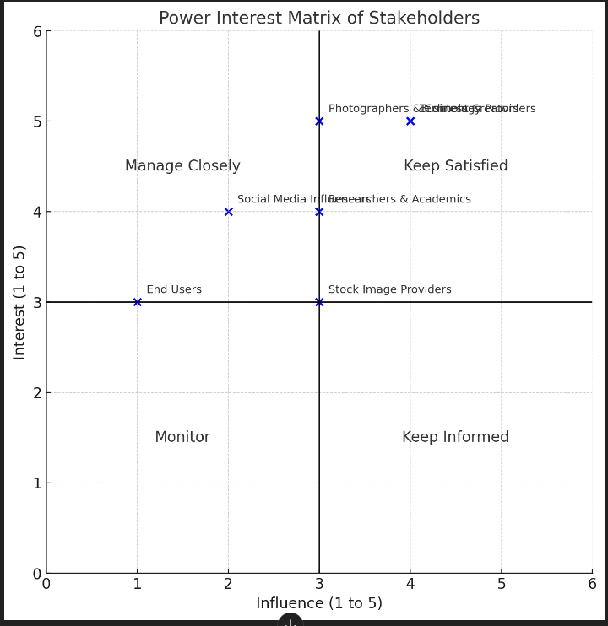

* **High Power, High Interest**: Technology Providers, Businesses (These stakeholders are crucial for success and have high stakes in the project's outcome.)
* **High Power, Moderate Interest**: Researchers & Academics (They have significant influence in the development of the project, though their interest is more academic.)
* **Moderate Power, High Interest**: Photographers & Content Creators (Their feedback and content are vital, but their influence on technology is moderate.)
* **Moderate Power, Moderate Interest**: Social Media Influencers, Stock Image Providers (They are interested in the system, but their power to affect it is moderate.)
* **Low Power, Low Interest**: End Users (Although they benefit from the system, their power and direct interest are lower compared to other stakeholders.) ​​

1. **Empathetic Interviews**

**Conduct Skilled interview with at least 30 citizens/Users by asking open ended questions (What, why/How etc) and list the insights as per the format below**

|  |  |  |
| --- | --- | --- |
| **I need to know**  **(thoughts, feelings, actions)** | **Questions I will ask**  **(open questions)** | **Insights I hope to gain** |
| Thoughts |  |  |
|  |  |  |
|  |  |  |
| Feelings |  |  |
|  |  |  |
|  |  |  |
| actions |  |  |
|  |  |  |
|  |  |  |

**SKILLED INTERVIEW REPORT**

**(Examples are given. Erase them and fill with your user information.)**

|  |  |  |
| --- | --- | --- |
| **User/Interviewee** | **Questions Asked** | **Insights gained (NOT THEIR ANSWERS)** |
| Abhishek Verma,  Student | Which party do you vote for? | Citizens are not very open about their political preferences |
| Srinivasan P., Parent | How do you feel about the plans for a new capital? | Some citizens are sad that the capital is being relocated from Hyderabad. |
|  |  |  |
|  |  |  |
|  |  |  |

**Key Insights Gained:**

* **Insight 1**
* **Insight 2**

**Empathy Map**

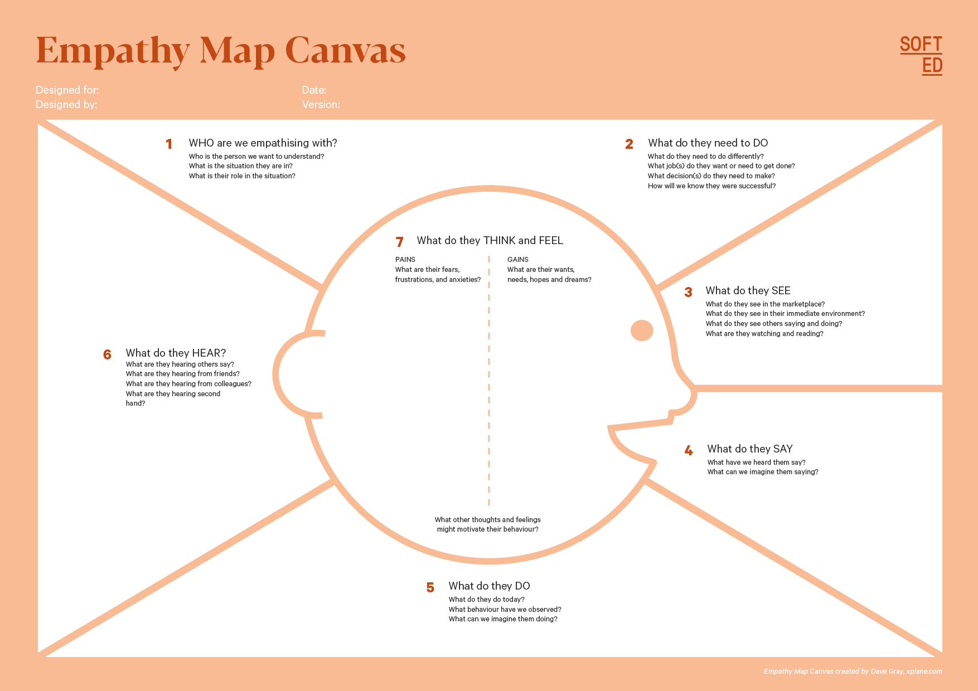

Your Answer:

Your Answer:

Who is your Customer Segment:

Idea/Innovation Title:

Designed By:

Date of Submission:

Your Answer:

Your Answer:

Your Answer:

Your Answer:

Your Answer:

Your Answer:

Your Answer:

1. **Empathy Map**
2. **Who is your Customer?**

**Description: This is where you specify the customer or user you are empathizing with. It could be a specific user persona or a general user segment.**

**Key points:**

* **Define the customer profile clearly (e.g., age, profession, interests).**
* **State their goals and needs related to the innovation or product.**
* **Context in which the user will interact with your solution.**

1. **Who are we empathizing with?**

**Description: This area helps you define who the user is, what their situation looks like, and what role they play. It emphasizes understanding the user’s perspective in depth.**

**Key points:**

* **Define the user's characteristics (e.g., personality, values, and responsibilities).**
* **State the user's goals and challenges in their environment.**
* **What is the user's broader situation (professionally or personally)?**

1. **What do they need to DO?**

**Description: This section identifies what actions or tasks the user needs to perform. It helps highlight the expectations and demands the user faces.**

**Key points:**

* **Clarify the tasks or actions the user needs to complete.**
* **What decisions do they need to make?**
* **How do they define success or failure in their tasks?**

1. **What do they SEE?**

**Description: This focuses on the visual stimuli or environment that the user interacts with. It's important to consider what users see in their immediate surroundings and in their larger world.**

**Key points:**

* **What do users see in their physical and digital environment?**
* **What trends or competitors do they notice?**
* **How do these visual elements influence their behavior?**

1. **What do they SAY?**

**Description: This section captures what the user might say in public, such as comments or feedback they give in conversations or on social media.**

**Key points:**

* **What might users express openly in conversation about their problems?**
* **How do they express their goals or frustrations?**
* **What are their words during customer interviews or feedback?**

1. **What do they DO?**

**Description: This section focuses on what the user does, the actual behaviors they exhibit, and actions they take in different situations.**

**Key points:**

* **What observable actions do users take?**
* **What habits or routines do they follow?**
* **What might users do to try and solve their problems?**

1. **What do they HEAR?**

**Description: This addresses what information the user receives from external sources, such as colleagues, media, or industry trends. It helps map the influences surrounding the user.**

**Key points:**

* **What are they hearing from peers, mentors, or the industry?**
* **What media or channels of information are they exposed to?**
* **Are there any strong influencers guiding their behavior?**

1. **What do they THINK and FEEL?**

**Description: This is one of the most insightful sections, addressing the internal emotions, concerns, and motivations of the user. It helps identify their deep-rooted feelings.**

**Key points:**

* **What are their fears, worries, and anxieties?**
* **What are their motivations and desires?**
* **How do their thoughts and feelings align with their actions?**

1. **Pains and Gains**

**Description: This section focuses on the user’s frustrations and their desired outcomes. It helps to frame the user’s challenges (pains) and the benefits they seek (gains).**

**Key points:**

* **What are the user’s main pain points?**
* **What would make their life easier or more fulfilling?**
* **What benefits do they hope to achieve from your product or solution?**

**8. Persona of Stakeholders**

**Stakeholder Name:**

**Demographics: Key characteristics of your target audience, such as age, gender, income, and location.**

**Goals: What the stakeholders or customers want to achieve in relation to the innovation.**

**Challenges: The obstacles or difficulties faced by stakeholders that the innovation aims to address.**

**Aspiration: The long-term desires or dreams of your target audience related to the innovation.**

**Needs: The essential requirements of your customers or stakeholders that must be met.**

**Pain Points: Specific problems or frustrations experienced by the target audience.**

**Storytelling: A narrative that highlights the journey of the stakeholder or customer, illustrating the problem and how the innovation can solve it.**

**Sample:**

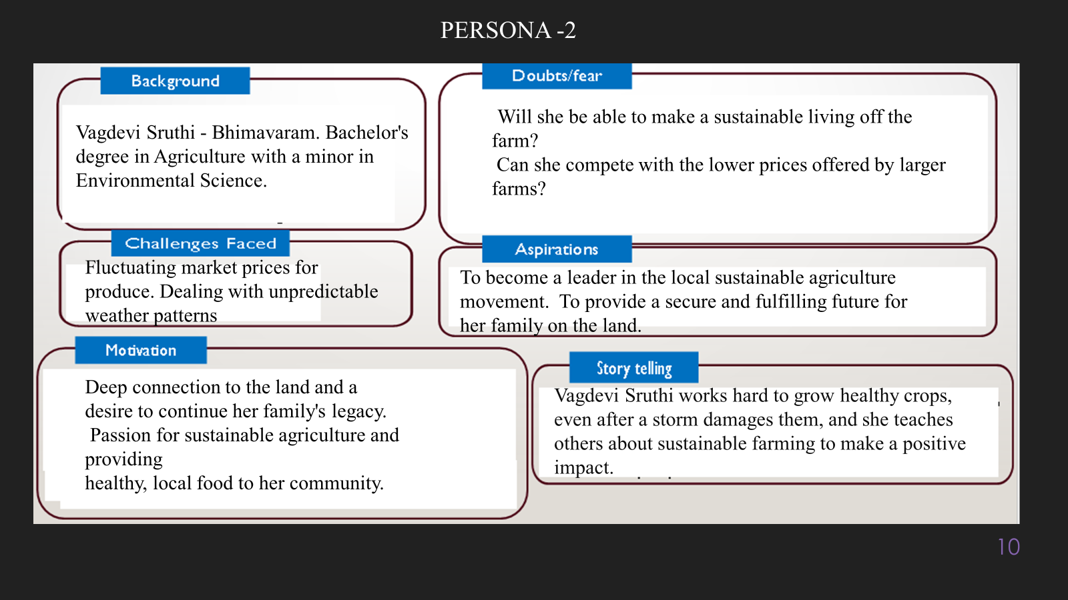

**10. Look for Common Themes, Behaviors, Needs, and Pain Points among the Users**

Analyse the data from your affinity diagram to uncover recurring patterns among your users, helping you better understand their expectations and challenges.

**Common Themes: Identify broad ideas or issues that repeatedly appear across different groups in your affinity diagram.**

**Common Behaviors: Observe how users consistently act or respond in relation to the problem or product throughout their journey.**

**Common Needs: Pinpoint essential requirements or desires that many users share, highlighting what they need for a better experience.**

**Common Pain Points: Look for frustrations or obstacles that frequently hinder the user experience, which your project can address.**

**12. Define Needs and Insights of Your Users**

**User Needs: Define the core requirements your users have in relation to the problem or product. These could be functional, emotional, or societal needs that your solution must address.**

**User Insights: Summarize the key understandings or observations you've uncovered about your users' behaviors, motivations, and pain points. These insights provide a deeper understanding of why users behave the way they do and what drives their decisions.**

**13. POV Statements**

**POV Statements:**

* [User] needs a way to [need] because [insight].

|  |  |  |  |
| --- | --- | --- | --- |
| PoV Statements  (At least ten) | Role-based or Situation-Based | Benefit, Way to Benefit,  Job TBD,  Need (more/less) | PoV Questions  (At least one per statement) |
| (Erase this example) When I drive to work, I want to avoid traffic jams so I don’t get in trouble with my boss for being late. | Situation | Way to Benefit | What can we design that will enable drivers to avoid traffic jams?  What can we design that will enable workers to avoid getting in trouble for being late to work? |
|  |  |  |  |
|  |  |  |  |
|  |  |  |  |
|  |  |  |  |

**14. Develop POV/How Might We (HMW) Questions to Transform Insights/Needs into Opportunities for Design**

Turn your user needs and insights into actionable opportunities by framing them as "How Might We" (HMW) questions. These questions will spark creative problem-solving and guide your innovation process.

1. **How Might We: Based on the needs and insights you've identified, create open-ended questions starting with "How might we...?" These questions should aim to solve user pain points, enhance the experience, or address specific needs.**

**Examples:**

* **User Need: "Users need a quicker way to access customer support."**
  + **HMW Question: "How might we create a more efficient and accessible customer support system?"**
* **Insight: "Users feel overwhelmed by too many options."**
  + **HMW Question: "How might we simplify decision-making for our users?"**

**Task:**

**Write 3-5 "How Might We" questions based on your analysis of user needs and insights. These questions should challenge you to think of innovative solutions that can address user problems in meaningful ways.**

**This task encourages participants to think creatively about solving user problems, transforming challenges into opportunities for innovation.**

|  |  |
| --- | --- |
| User Need/Insight | "How Might We" Question |
| [State the user need or insight clearly] | **How might we... [formulate an open-ended question to address the need or insight]?** |

**16. Crafting a Balanced and Actionable Design Challenge**

The Design Challenge Should Neither Be Too Narrow Nor Too Broad and It Should Be an Actionable Statement with a quantifiable goal. It should be a culmination of the POV questions developed.

**Design Challenge:** [Actionable Statement]

**17. Validating the Problem Statement with Stakeholders for Alignment**

Ensure your problem statement accurately represents the needs and concerns of your stakeholders and users. This involves gathering feedback from these groups to confirm that the problem is relevant and significant from their perspective. By validating early, you can refine the problem statement to better align with real-world challenges, ensuring your solution addresses the correct issues.

**Validation Plan:**

**Stakeholder/User Feedback (Min. 10 Stakeholders/Experts):**

|  |  |  |  |
| --- | --- | --- | --- |
| Stakeholder/User | Role | Feedback on Problem Statement | Suggestions for Improvement |
| [Name/Group] | **[Role/Title]** | **[Does the problem resonate with them? Why or why not?]** | **[Suggestions for refining the problem statement]** |
| [Name/Group] | **[Role/Title]** | **[Does the problem resonate with them? Why or why not?]** | **[Suggestions for refining the problem statement]** |

**18. Ideation**

**Ideation Process:**

|  |  |  |  |
| --- | --- | --- | --- |
| Idea Number | Proposed Solution | Key Features/Benefits | Challenges/Concerns |
| Idea 1 | **[Brief description of solution]** | **[What are the key benefits of this solution?]** | **[What challenges or concerns exist?]** |
| Idea 2 | **[Brief description of solution]** | **[What are the key benefits of this solution?]** | **[What challenges or concerns exist?]** |
| Idea 3 | **[Brief description of solution]** | **[What are the key benefits of this solution?]** | **[What challenges or concerns exist?]** |
| Idea 4 | **[Brief description of solution]** | **[What are the key benefits of this solution?]** | **[What challenges or concerns exist?]** |
| Idea 5 | **[Brief description of solution]** | **[What are the key benefits of this solution?]** | **[What challenges or concerns exist?]** |

**18. Idea Evaluation**

Evaluate the Idea based on 10/100/1000 grams

|  |  |  |  |  |
| --- | --- | --- | --- | --- |
| Idea | Impact (10/100/1000 grams) | Feasibility (10/100/1000 grams) | Alignment (10/100/1000 grams) | Total Weight |
| Idea 1 | **[Assign weight]** | **[Assign weight]** | **[Assign weight]** | **[Sum of weights]** |
| Idea 2 | **[Assign weight]** | **[Assign weight]** | **[Assign weight]** | **[Sum of weights]** |
| Idea 3 | **[Assign weight]** | **[Assign weight]** | **[Assign weight]** | **[Sum of weights]** |
| Idea 4 | **[Assign weight]** | **[Assign weight]** | **[Assign weight]** | **[Sum of weights]** |
| Idea 5 | **[Assign weight]** | **[Assign weight]** | **[Assign weight]** | **[Sum of weights]** |

**Example:**

|  |  |  |  |  |
| --- | --- | --- | --- | --- |
| Idea | Impact (10/100/1000 grams) | Feasibility (10/100/1000 grams) | Alignment (10/100/1000 grams) | Total Weight |
| Idea 1 | **1000** | **100** | **1000** | **2100** |
| Idea 2 | **100** | **1000** | **100** | **1200** |
| Idea 3 | **100** | **100** | **100** | **300** |

Further, use solution concept form to scrutinize the idea

**Solution Concept Form**

**1. Problem Statement:**

* **[State the validated problem your solution addresses.]**

**2. Target Audience:**

* **[Describe the main users or customers who will benefit from this solution.]**

**3. Solution Overview:**

* **[Provide a brief description of the solution concept.]**

**4. Key Features:**

| **Feature** | **Description** |
| --- | --- |
| **Feature 1** | **[Briefly describe the main feature of your solution]** |
| **Feature 2** | **[Briefly describe another key feature]** |
| **Feature 3** | **[Briefly describe a third key feature]** |

**5. Benefits:**

| **Benefit** | **Description** |
| --- | --- |
| **Benefit 1** | **[What value does this solution bring?]** |
| **Benefit 2** | **[How does this solution solve the problem?]** |
| **Benefit 3** | **[What makes this solution stand out?]** |

**6. Unique Value Proposition (UVP):**

* **[Summarize why this solution is unique and why it will appeal to your target audience.]**

**7. Key Metrics:**

| **Metric** | **Measurement** |
| --- | --- |
| **Metric 1** | **[What is the key metric to measure success?]** |
| **Metric 2** | **[What is another key metric for tracking progress?]** |

**8. Feasibility Assessment:**

* **[Provide a brief evaluation of how achievable or practical this solution is (consider resources, time, and technology).]**

**9. Next Steps:**

* **[Outline the next steps for further developing or prototyping this solution.]**